1. Explain the difference between the = operator and the == operator in Python

**“=” Operator:** In Python = symbol is defined as **assignment**operator. It requires one variable on its left and an expression on its right. Value of the expression on right is assigned to variable on left. Expression and name of variable are not interchangeable.

**Example:** a = 10, here integer '10' is assigned to the variable named "a"

**Program:**

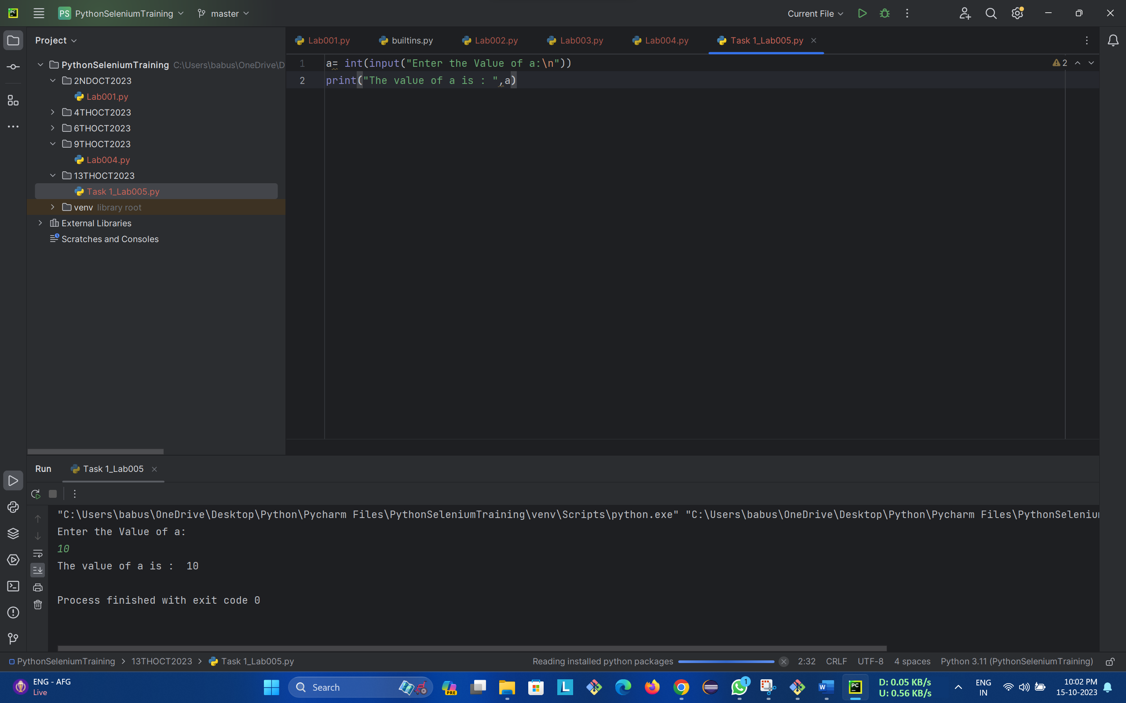

**“==” Operator:** The == symbol is a comparison operator and called **equal to** operator. It returns true if operands on either side are equal, otherwise it returns false

**Example:** a = 10

if(a == 10): --> Here the value in variable a is compared with integer 10 and returns True if equal else returns false

print(True)

else:

print(False)

Result will be =True

**Program:**

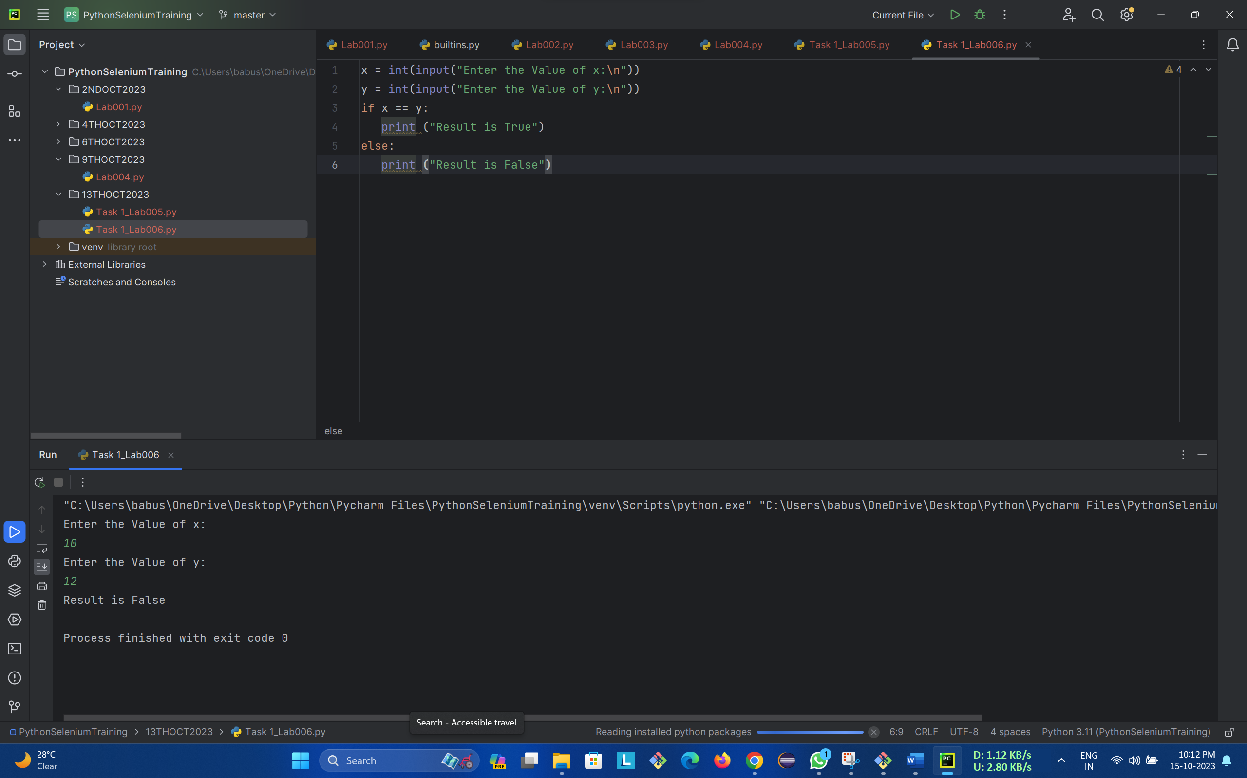

2. What does the ** operator do in Python, and how is it used?

**“**”Operator:** In Python, the ** operator is used for exponentiation. It raises a number to a given power. It is basically E to power. It raises a number to a specific power. It is also known as the "power" or "exponentiation" operator.

The ** operator works with both integers and floating-point numbers.

**Example:**

X=8

Y=3

Print (x**Y) = 8 raise to power 3

Result will be = 512

**Program:**

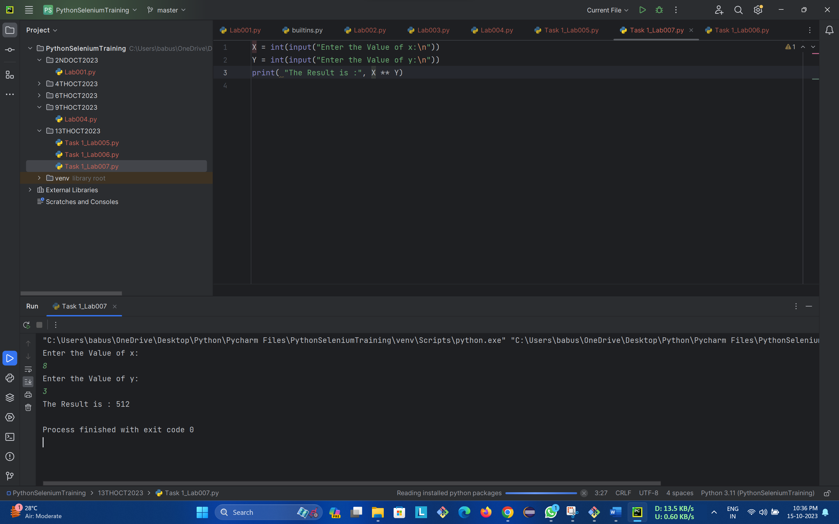

3. What does the ^ operator do in Python, and in what context is it commonly used?

**“^” Operator:** It is a bitwise XOR operator Results bit 1, if any of the operand bit is 1 but not both, otherwise results bit 0. Which means if both are zero then result will be 0 and both are 1 then result will be zero other than result will be always 1.

**Example:** Let X = 10 (0000 1010 in binary) and Y = 4 (0000 0100 in binary), The XOR Operation will give the result, X^Y = 14

X = 10 🡪 0 0 0 0 1 0 1 0

Y = 4 🡪 0 0 0 0 0 1 0 0

X^Y= 14 🡪 0 0 0 0 1 1 1 0

**Program:**

